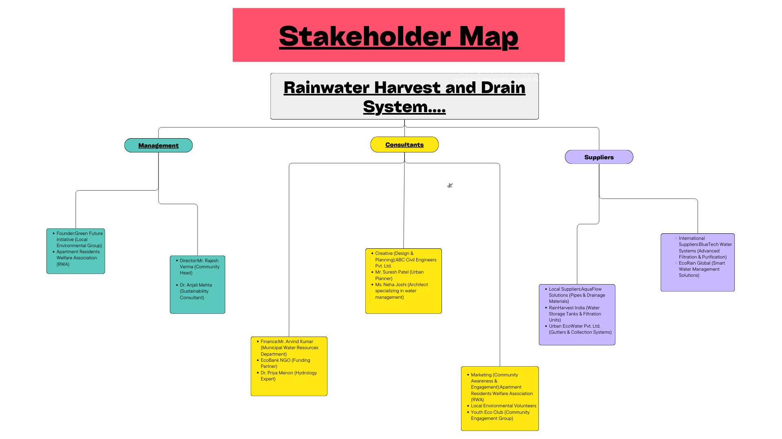**Task Overview: Rainwater Harvest and Drain System in a Community Apartment..**

**Introduction:**

Rainwater harvesting is an essential strategy to ensure water sustainability, especially in urban residential areas like community apartments. This project focuses on implementing an efficient rainwater harvesting and drainage system to optimize water conservation, reduce dependency on municipal water supply, and manage excess rainwater effectively.

**Project Objectives:**

1. **Water Conservation** – Reduce wastage by collecting and storing rainwater for domestic and community use.
2. **Flood Prevention** – Implement proper drainage to avoid waterlogging and soil erosion.
3. **Sustainability** – Promote eco-friendly initiatives to improve water security in the community.
4. **Community Awareness** – Engage residents in sustainable water management practices.

**Stakeholder Roles & Responsibilities:**

**1. Management**

Responsible for decision-making, policy implementation, and community engagement.

* **Local Environmental Groups (Green Future Initiative, RWA)** – Support and promote awareness within the community.
* **Community Heads (Rajesh Verma, Dr. Anjali Mehta)** – Oversee project execution, liaise with stakeholders, and ensure compliance with sustainability goals.

**2. Consultants**

Expert professionals providing technical guidance and planning.

* **Urban Planners & Engineers** – ABC Civil Engineers Pvt. Ltd., Mr. Suresh Patel, and Ms. Neha Joshi will design and develop an efficient water management system.
* **Hydrology Experts & Financial Consultants** – Dr. Priya Menon and Mr. Arvind Kumar ensure feasibility, funding, and efficiency of the system.

**3. Suppliers**

Provide necessary materials and technology.

* **Local Suppliers** – AquaFlow Solutions (pipes & drainage), RainHarvest India (storage tanks & filtration), Urban EcoWater (gutters & collection systems).
* **International Suppliers** – BlueTech Water Systems (advanced filtration), EcoRain Global (smart water management).

**Implementation Plan:**

**Phase 1: Planning & Design**

* Conduct a feasibility study and assess rainwater collection potential.
* Design an optimal system considering rooftop collection, storage, and drainage.

**Phase 2: Procurement & Installation**

* Acquire materials from local and international suppliers.
* Install collection tanks, filtration units, and drainage pipelines.

**Phase 3: Awareness & Training**

* Conduct workshops for residents on water conservation practices.
* Establish maintenance teams to ensure long-term functionality.

**Phase 4: Monitoring & Maintenance**

* Regular inspection of storage tanks, pipelines, and filtration systems.
* Evaluate the impact on water consumption and community awareness.

**Conclusion:**

A well-planned rainwater harvesting and drainage system can transform a community apartment into a water-resilient environment. With collaboration between **management, consultants, and suppliers**, this project ensures a **sustainable and eco-friendly water solution** benefiting both residents and the environment.